


77
Provide bell boy/porter services
D1.HFO.CL2.07
Trainee Manual


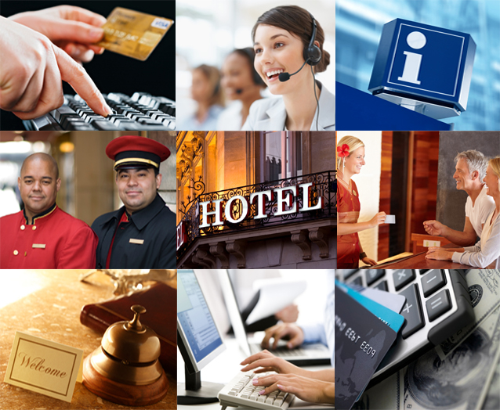



Provide bell boy/porter services

D1.HFO.CL2.07

Trainee Manual





Project Base
William Angliss Institute of TAFE
555 La Trobe Street
Melbourne 3000 Victoria
Telephone: | (03) 9606 2111
Facsimile: | (03) 9670 1330
Acknowledgements
Project Director: | Wayne Crosbie
Chief Writer: | Alan Hickman
Subject Writers: | Evelyn Collins and Linda Wilson
Project Manager: | Alan Maguire
Editor: | Jim Irwin
DTP/Production: | Daniel Chee, Mai Vu, Jirayu Thangcharoensamut, Kaly Quach

The Association of Southeast Asian Nations (ASEAN) was established on 8 August 1967. The Member States of the Association are Brunei Darussalam, Cambodia, Indonesia, Lao PDR, Malaysia, Myanmar, Philippines, Singapore, Thailand and Viet Nam.
The ASEAN Secretariat is based in Jakarta, Indonesia.
General Information on ASEAN appears online at the ASEAN Website: www.asean.org.
All text is produced by William Angliss Institute of TAFE for the ASEAN Project on “Toolbox Development for Front Office, Food and Beverage Services and Food Production Divisions”.
This publication is supported by the Australian Government’s aid program through the ASEAN-Australia Development Cooperation Program Phase II (AADCP II).
Copyright: Association of Southeast Asian Nations (ASEAN) 2013.
All rights reserved.
Disclaimer
Every effort has been made to ensure that this publication is free from errors or omissions. However, you should conduct your own enquiries and seek professional advice before relying on any fact, statement or matter contained in this book. The ASEAN Secretariat and William Angliss Institute of TAFE are not responsible for any injury, loss or damage as a result of material included or omitted from this course. Information in this module is current at the time of publication. Time of publication is indicated in the date stamp at the bottom of each page.
Some images appearing in this resource have been purchased from stock photography suppliers Shutterstock and iStockphoto and other third party copyright owners and as such are non-transferable and non-exclusive. Clip arts, font images and illustrations used are from the Microsoft Office Clip Art and Media Library. Some images have been provided by and are the property of William Angliss Institute.
Additional images have been sourced from Flickr and SXC and are used under Creative Commons licence: http://creativecommons.org/licenses/by/2.0/deed.en
File name: TM_Provide_bell_boy-porter_services_refined.docx





Table of Contents
Introduction to trainee manual 1
Unit descriptor 3
Assessment matrix 5
Glossary 7
Element 1: Identify the role of a bell boy/porter 9
Element 2: Assist with guest arrivals 17
Element 3: Assist with guest departures 27
Element 4: Assist other departments 33
Element 5: Provide concierge services 39
Presentation of written work 47
Recommended reading 49
Trainee evaluation sheet 51
Trainee self-assessment checklist 53

Introduction to trainee manual

To the Trainee
Congratulations on joining this course. This Trainee Manual is one part of a ‘toolbox’ which is a resource provided to trainees, trainers and assessors to help you become competent in various areas of your work.
The ‘toolbox’ consists of three elements:
- A Trainee Manual for you to read and study at home or in class
- A Trainer Guide with Power Point slides to help your Trainer explain the content of the training material and provide class activities to help with practice
- An Assessment Manual which provides your Assessor with oral and written questions and other assessment tasks to establish whether or not you have achieved competency.
The first thing you may notice is that this training program and the information you find in the Trainee Manual seems different to the textbooks you have used previously. This is because the method of instruction and examination is different. The method used is called Competency based training (CBT) and Competency based assessment (CBA). CBT and CBA is the training and assessment system chosen by ASEAN (Association of South-East Asian Nations) to train people to work in the tourism and hospitality industry throughout all the ASEAN member states.
What is the CBT and CBA system and why has it been adopted by ASEAN?
CBT is a way of training that concentrates on what a worker can do or is required to do at work. The aim is of the training is to enable trainees to perform tasks and duties at a standard expected by employers. CBT seeks to develop the skills, knowledge and attitudes (or recognise the ones the trainee already possesses) to achieve the required competency standard. ASEAN has adopted the CBT/CBA training system as it is able to produce the type of worker that industry is looking for and this therefore increases trainees’ chances of obtaining employment.
CBA involves collecting evidence and making a judgement of the extent to which a worker can perform his/her duties at the required competency standard. Where a trainee can already demonstrate a degree of competency, either due to prior training or work experience, a process of ‘Recognition of Prior Learning’ (RPL) is available to trainees to recognise this. Please speak to your trainer about RPL if you think this applies to you.
What is a competency standard?
Competency standards are descriptions of the skills and knowledge required to perform a task or activity at the level of a required standard.
242 competency standards for the tourism and hospitality industries throughout the ASEAN region have been developed to cover all the knowledge, skills and attitudes required to work in the following occupational areas:
- Housekeeping
- Food Production
- Food and Beverage Service
- Front Office
- Travel Agencies
- Tour Operations.
All of these competency standards are available for you to look at. In fact you will find a summary of each one at the beginning of each Trainee Manual under the heading ‘Unit Descriptor’. The unit descriptor describes the content of the unit you will be studying in the Trainee Manual and provides a table of contents which are divided up into ‘Elements’ and ‘Performance Criteria”. An element is a description of one aspect of what has to be achieved in the workplace. The ‘Performance Criteria’ below each element details the level of performance that needs to be demonstrated to be declared competent.
There are other components of the competency standard:
- Unit Title: statement about what is to be done in the workplace
- Unit Number: unique number identifying the particular competency
- Nominal hours: number of classroom or practical hours usually needed to complete the competency. We call them ‘nominal’ hours because they can vary e.g. sometimes it will take an individual less time to complete a unit of competency because he/she has prior knowledge or work experience in that area.
The final heading you will see before you start reading the Trainee Manual is the ‘Assessment Matrix’. Competency based assessment requires trainees to be assessed in at least 2 – 3 different ways, one of which must be practical. This section outlines three ways assessment can be carried out and includes work projects, written questions and oral questions. The matrix is designed to show you which performance criteria will be assessed and how they will be assessed. Your trainer and/or assessor may also use other assessment methods including ‘Observation Checklist’ and ‘Third Party Statement’. An observation checklist is a way of recording how you perform at work and a third party statement is a statement by a supervisor or employer about the degree of competence they believe you have achieved. This can be based on observing your workplace performance, inspecting your work or gaining feedback from fellow workers.
Your trainer and/or assessor may use other methods to assess you such as:
- Journals
- Oral presentations
- Role plays
- Log books
- Group projects
- Practical demonstrations.
Remember your trainer is there to help you succeed and become competent. Please feel free to ask him or her for more explanation of what you have just read and of what is expected from you and best wishes for your future studies and future career in tourism and hospitality.

Unit descriptor
Provide bell boy/porter services
This unit deals with the skills and knowledge required to Provide bell boy/porter services in a range of settings within the hotel and travel industries workplace context.
Unit Code:
D1.HFO.CL2.07
Nominal Hours:
15 hours

Element 1: Identify the role of a bell boy/porter
Performance Criteria
1.1 Describe the services delivered by a bell boy/porter
1.2 Locate the position of bell boy/porter within the enterprise
1.3 Identify the personal characteristics required of a bell boy/porter
1.4 Describe grooming and personal presentation standards for a bell boy/porter
1.5 Interpret enterprise policies and procedures for the provision of bell boy/porter services
1.6 Identify and explain the role of communication in bell boy/porter service provision

Element 2: Assist with guest arrivals
Performance Criteria
2.1 Prepare for expected guest arrivals
2.2 Comply with special requests
2.3 Assist guests on arrival as required
2.4 Escort guests to rooms
2.5 Adhere to enterprise policies and procedures for luggage handling

Element 3: Assist with guest departures
Performance Criteria
3.1 Respond to guest requests for help when departing
3.2 Transport luggage for departing guests
3.3 Operate in-house guest luggage storage facilities

Element 4: Assist other departments
Performance Criteria
4.1 Support room service requests for assistance
4.2 Provide general fetching and carrying duties for departments as appropriate
4.3 Assist in emergency cleaning requirements
4.4 Assist in emergency situations and procedures, as required
4.5 Back-fill in departments and service areas where required
4.6 Manage difficult patrons

Element 5: Provide concierge services
Performance Criteria
5.1 Distribute mail and messages to guests
5.2 Arrange wake-up calls for guests
5.3 Organise transport for guests during their stay
5.4 Arrange transfers for departing guests
5.5 Organise luggage pick-up from rooms and destinations
5.6 Page guests as required
5.7 Prepare in-house guest information/directories
5.8 Respond to guest requests for advice and local knowledge

Assessment matrix
Showing mapping of Performance Criteria against Work Projects, Written Questions and Oral Questions
The Assessment Matrix indicates three of the most common assessment activities your Assessor may use to assess your understanding of the content of this manual and your performance – Work Projects, Written Questions and Oral Questions. It also indicates where you can find the subject content related to these assessment activities in the Trainee Manual (i.e. under which element or performance criteria). As explained in the Introduction, however, the assessors are free to choose which assessment activities are most suitable to best capture evidence of competency as they deem appropriate for individual students.
 |  |  | Work Projects | Written Questions | Oral Questions
Element 1: Identify the role of a bell boy/porter
1.1 | Describe the services delivered by a bell boy/porter |  | 1.1 | 1 | 1
1.2 | Locate the position of bell boy/porter within the enterprise |  | 1.2 | 2 | 2
1.3 | Identify the personal characteristics required of a bell boy/porter |  | 1.3 | 3 | 3
1.4 | Describe grooming and personal presentation standards for a bell boy/porter |  | 1.4 | 4 | 4
1.5 | Interpret enterprise policies and procedures for the provision of bell boy/porter services |  | 1.5 | 5 | 5
1.6 | Identify and explain the role of communication in bell boy/porter service provision |  | 1.6 | 6 | 6
Element 2: Assist with guest arrivals
2.1 |  | Prepare for expected guest arrivals | 2.1 | 7 | 7
2.2 |  | Comply with special requests | 2.2 | 8 | 8
2.3 |  | Assist guests on arrival as required | 2.3 | 9, 10 | 9
2.4 |  | Escort guests to rooms | 2.4 | 11, 12 | 10
2.5 |  | Adhere to enterprise policies and procedures for luggage handling | 2.5 | 13, 14, 15 | 11
Element 3: Assist with guest departures
3.1 | Respond to guest requests for help when departing |  | 3.1 | 16 | 12
3.2 | Transport luggage for departing guests |  | 3.2 | 17 | 13
3.3 | Operate in-house guest luggage storage facilities |  | 3.3 | 19 | 14
Element 4: Assist other departments
4.1 |  | Support room service requests for assistance | 4.1 & 4.2 | 20 | 15
4.2 |  | Provide general fetching and carrying duties for departments as appropriate | 4.1 & 4.2 | 21 | 16
4.3 |  | Assist in emergency cleaning requirements | 4.3 | 22 | 17
4.4 |  | Assist in emergency situations and procedures, as required | 4.4 | 23. | 18
4.5 |  | Back-fill in departments and service areas where required | 4.5 | 24 | 19
4.6 |  | Manage difficult patrons | 4.6 | 25 | 20
Element 5: Provide concierge services
5.1 | Distribute mail and messages to guests |  | 5.1 | 31 | 21
5.2 | Arrange wake-up calls for guests |  | 5.2 | 26 | 22
5.3 | Organise transport for guests during their stay |  | 5.3 & 5.8 | 27 | 23
5.4 | Arrange transfers for departing guests |  | 5.4 & 5.5 | 28 | 24
5.5 | Organise luggage pick-up from rooms and destinations |  | 5.4 & 5.5 | 18 | 25
5.6 | Page guests as required |  | 5.6 | 32 | 26
5.7 | Prepare in-house guest information/directories |  | 5.7 | 29 | 27
5.8 | Respond to guest requests for advice and local knowledge |  | 5.3 & 5.8 | 30 | 28

Glossary
Term | Explanation
Bell Desk | The desk located in the lobby close to and visible by the front desk
Bell Boy | A member of the uniformed staff who is responsible for messages or running errands
Concierge | A European term describing the person in charge of the Bell or Porter staff who deals with guests needs and special requests
Porter | The staff who welcome guests, manage guest luggage and provide general information for guests and handle special requests
Rating system | A method of ranking hotel services and features to establish a standard of service.
Luggage | The articles and suitcases etc that accompany the guest
Doorperson | The member of the uniformed staff who stands at the entrance to an accommodation venue opening doors to transport vehicles and the building
Guests room | The room with a bed and other features for guest use during their stay for which the guest will pay
Luggage trolley | Transport trolley of various types including railway trolley and bell domed trolley use to transport guest luggage
Front Office Manager | The common term used to describe the department head or manager who manages the reservation and reception area of a hotel or resort
In house services | These are all the services offered by the Hotel or Resort within their business such as restaurants, bars, leisure and entertainment. Also include the services provided in a guest room, internet, TV, movies etc
Guest services | The section of the venue which handles tour bookings, problem solves for guests and provides information for guests
Chauffeur | The member of the Uniformed staff who drives the venues cars or buses
Valet parking | A personalised service. The valet or porter will take the guests car from the entrance and park it in a pre allocated space
Rooms division | Include the departments or sections of a venue which deal specifically with in house guests
Honorific | A person's title e.g. Mr, Mrs, Dr, Ms etc
Etiquette | Etiquette is the set of customary rules for behaviour in polite society
Target markets | A category of people who have been identified as potential customers because of their needs or reasons for travel
VIP | Very Important Persons. Guests who are regulars, high ranking Government or industry officials, foreign dignitaries or titled guest, famous celebrities or royalty
Property Management System (P.M.S) | A system of keeping track of controlling financial and non financial activities in an accommodation venue. It may be manual, semi automated or fully automated
Guest history | Information and statistics from a guest previous stays
Arrivals Report | Names, details , times and numbers of guests expected to arrive on a specific date
Departure Report | Names, details , times and numbers of guests expected to depart on a specific date
Special reports | Details of all guest special requests for a specific date  Also called the trace report
ETA | Estimated Time of Arrival
ETD | Estimated Time of departure
Guests itinerary | A detailed date and time list of proposed activities
Room the guest | The procedure for issuing the guest with a key and instructing them how to find their room. May include escorting by a porter
Rooming List | A list of guests in a group identifying arrival date and time, departure date and time , payment details and names including who is sharing with whom
Day Use rate | 50% of Rack rate charged to use a guest room from 9-5pm
Wake up call | A telephone call placed to a guest room at a pre requested time to wake them up
Guest profile | A record of guest’s personal details and contact details also includes linked preferences such as newspaper choice

Element 1:
Identify the role of a bell boy/porter

1.1 Describe the services delivered by a bell boy/porter

Introduction
Bell Boy or Porter services are a main feature of a luxury Hotel or resort, and a requirement for [5] five star or above rating system. In a lesser rated Hotel or resort there are still Bell Boy or Porter services but they are mainly to store guests luggage or provide trolleys.


Greeting Guests
When guests arrive a Porter will welcome them warmly with positive body language and a smile, usually naming the venue. A Porter will then assist them out of the car, bus or transport vehicle. If there is a need to have hands on help in assisting the guest to alight, steady the guest by supporting their elbow. Collect their luggage, checking the number and type of items then direct the guest to reception for check in. Porters may then deliver the luggage to the guest’s room. The doorperson will have the job of opening car and taxi doors as well as Hotel front doors. They also have the role of keeping the entrance way clear and stop cars from parking in the driveway. Many hotels have double entry doors and the Porters will need to assist the guest in navigating to the reception area. Self-opening doors will have time restriction or buttons to press.

Moving Guest luggage
Luggage needs to be collected from a transport vehicle and stacked on to a luggage trolley and moved to a holding area until the guest has checked in or had a room allocated then the porter will escort the guest to their room with their luggage. Guests may have special requests about the handling of their luggage, some guest with laptops or valuables prefer to carry them themselves. The guest may not need their entire luggage and request certain pieces are stored in the porter services storage area. Occasionally the luggage will arrive before the guest with instruction on how it is to be stored

Liaise with Front Office and other departments
Porters will liaise with the Front Office Manager and the Managers of other departments e.g. Room Service to ensure guest services standards are maintained. Front office reception will check any requests as guests check- in, porters may have to check requested items have been supplied when the escort the guest to their room. Porters will promote in house services and give recommendations to answer guest questions.
Other porter duties may include taking messages, packages or mail for in house guests in liaison with reception staff, supplying information to guests about in house services. Concierge and Porters are responsible for solving guest’s problems and answering queries about local tourist and recreational facilities. Porters will also arrange hire cars, booking transport or tours and Booking tickets to the theatres, sporting venues or other entertainment also Confirming travel arrangements e.g. airline tickets and Make restaurant reservations and bookings.

1.2 Locate the position of bell boy/porter within the enterprise

Introduction
The term Concierge is used to describe the supervisor or Department head in this area, the concierge is the person in charge of the uniformed staff. Uniformed staff comprise the porter, door person, guest services, chauffeurs, valet parking attendants and messengers, page or bell boys and lift attendants.

These staff are also known as “uniformed staff” because they often wear militaristic uniforms and are permitted to wear their uniforms outside the Hotel or Resort to do messages, errands or complete requests for guests. The Concierge or Bell desk supervisor report to the front office manager and come under the Rooms division department of the Hotel or resort. Rooms division refers to the cluster of departments who deal with Guests specifically and includes the Front Office, Housekeeping, Security, Maintenance, Room Service and Concierge.

1.3 Identify the personal characteristics required of a bell boy/porter

Introduction
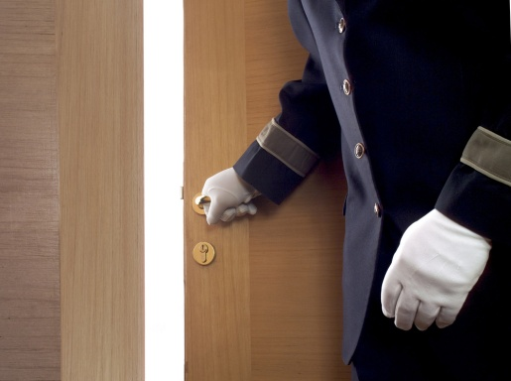
The first impression of the establishment is often affected by the way the guest is greeted; this includes the use of effective and appropriate non-verbal communication or body language. It is critical that the message sent by the body language is in-keeping with the verbal message sent. Porters need to be well prepared and ready when greeting guests, able to give prompt and courteous service. Be aware of cultural and behavioural conventions including the use of honorific’s and social etiquette.
The porter maintains constant contact with guests and must therefore possess certain qualities that are representative of the individual and the venue. The porter must be attentive and courteous to the guests needs and be organised in way they tackle every aspect of their job.
Guests will arrive tired, grumpy or stressed a porter has to be discrete, tactful and sympathetic to all situations. When a guest makes a difficult request a porter needs to be resourceful and know where to get things that others probably can’t. Good manners and knowledge of etiquette are essential as porters have first contact with the guest and set the tone for that guests stay.
A porter or member of the bell desk staff has to have a high level of product knowledge and highly developed selling skills, demonstrate excellent interpersonal skills, good social and communication skills and understand the various needs of the venues target markets.

1.4 Describe grooming and personal presentation standards for a bell boy/porter

Introduction
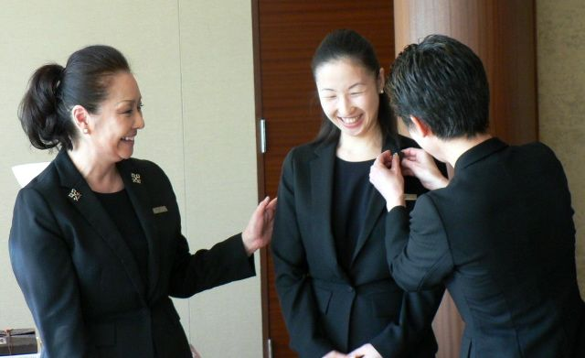
Porters should have a high regard for personal grooming and hygiene. Ethics and professionalism are important for staff in this area as seen in those Concierges who are members of the Le Clefs D’Or. This society is a worldwide organisation of concierges. It was started in France in 1952 by the head porter of a large Parisian hotel with the aim of uniting all hotel porters in an association based on friendship, solidarity and fraternity. Currently, all around the world, the crossed keys are proudly worn on the lapels of concierges and their assistants. The aims of Les Clefs D’Or include a wider recognition of the concierge and the importance of the concierge’s duties and a member of the Le Clefs D’Or projects an image and professionalism which can improve the status of a hotel. Le Clefs D'Or promotes Integrity and leadership, continuous concierge service, pride and respect in the position; and training of future concierges.
The value of membership therefore is likely to lie in providing porters with a high international standard of portering to follow and provide superior service to guests accordingly. A porter’s presentation will have a lasting impression on the guest and it is important that this impression be of the highest standard at all times. Guest expectations are that porters will look a certain way, clean and well-presented and it is important to meet those expectations regardless of what has taken place during the shift.
How Porters stand and move reflects on the image of the establishment, posture, body language and the speed of movement, demonstrate a porters commitment to the professionalism of the job. Remember that a uniform completes the physical side of a valet’s professional and personal presentation, and the uniform deserves merits and demands appropriate attention. The uniform is a key to personal presentation. While establishments provide and launder uniforms, staff must ensure it fits properly, is comfortable, is kept clean during work and remains in good repair. Establishments will have policies and procedures but the grooming standard expected may include:
- Good posture

- Basic jewellery
- Deodorant lightly scented
- Lightly-scented aftershave or perfume
- Make-up is kept natural
- Hygiene, good personal hygiene habits, cuts and sores must be kept covered with a clean dressing
- Clean shaven or whiskers neatly trimmed
- Hair neat and tidy and tied back, if appropriate
- Hands must be clean and well cared for at all times
- Good dental health
- Manicured nails with natural coloured polish
- Clean and pressed uniform
- Low heel, polished shoes.

1.5 Interpret enterprise policies and procedures for the provision of bell boy/porter services

The porter’s role is to provide a range of services to guests that may not be available through other departments. Despite not generating revenue, on a porter’s recommendation, a guest may use facilities and services offered by the venue that do earn revenue. A porter has excellent opportunity to read the guest and suggest a Hotel services that would help relax them. A tired guest may like a sauna or massage in the spa or that a family would like a babysitter so the parents can eat dinner alone. Porters are required to give an honest recommendation and offer extra information about dress codes, payment options or transport.
Porters will assist VIPs. Hotels and Resorts offer a level of courtesy, security and privacy over and above regular guests. VIPs are often ranked and include regular guests, government officials, Company executive, foreign dignitary, celebrities, titled people and even royalty. There may be a policy and protocols for addressing and escorting VIPs to their rooms. Some VIPs will require extreme privacy others may want fans and others to make a fuss. VIPs will have a range of Amenities or complementary items delivered to their rooms, fruit baskets, wine or local produce baskets, these amenities will differ according to the VIP ranking. Other services may include greeting by the general manager or additional security. When greeting High ranking officials or Royalty there may be explicit instructions on what is expected such as how to address the guest and include details about relevant information that could impact on the guests stay.
A porter may have discretionary authority to offer guests special services such as private use of facilities at pre-arranged times such as the fitness area or sauna.

1.6 Identify and explain the role of communication in bell boy/porter service provision
The first impression of the establishment is often affected by the way the guest is greeted; inherent in this is the use of effective and appropriate non-verbal communication (body language). It is critical that the message sent by the body language is in-keeping with the verbal message sent. Porters need to be well prepared and ready when greeting guests, able to give prompt and courteous service. Be aware of cultural and behavioural conventions including the use of honorifics and social etiquette.
Whatever the scenario, the porter must greet and direct the guest in a professional and welcoming manner each and every time: this may sound easy but it can become repetitive and draining. When and where appropriate, the porter should adhere to the following guidelines; use the guest’s name, if known and appropriate, electronic property management system will enable Porters to access guest arrival details and profile information.
When addressing Guests a porter should look at the guest and speak clearly, accurately, and with the appropriate volume it may be appropriate to use body language to show the way, if necessary always smile, be courteous and polite.
Keep the conversation on a professional level and a positive note know when to talk and when to be quiet, as some guests do not wish to speak. Do not give out any hotel secrets.
Porters will spend individual time with a guest escorting them to their room and start building rapport means establishing a relation and connection with the guest.
To achieve these outcomes when communicating with the guest, the porter needs to:
- Conduct themselves in a professional manner
- Act politely and show courtesy
- Demonstrate correct etiquette at all times: etiquette can be described as manners, decorum and propriety – etiquette is the set of customary rules for behaviour in polite society
- Speak clearly and concisely
- Use the guest’s name at all times
- Be truthful at all times
- Exhibit a constant willingness to assist
- Maintaining confidentiality is a requirement for a Porter and other room division staff.
Porters have access to a guest’s private life the guest may discuss private and personal business matters or activities or other aspects of life that are not for public consumption.
And a Porter must respect the guest’s privacy on all matters they overhear or are told and treat them as being in the strictest of confidence, in some cases, a porter may be asked to sign a confidentiality clause or contract that stipulates that guest history, activities and other matters will be kept in the strictest of confidence.
Every establishment will have their own policies and procedures on this matter, but the intent is the same – to maintain the guest’s trust by keeping private matters, private.
The Bell desk /concierge/Porter service offers the guest services and solves problems for the guest. A porter may be requested to arrange hire cars, book transport or tours, Book tickets to the theatres, sporting venues or other entertainment. Porter guest services or bell desk may also need to confirm travel arrangements such as airline tickets, and to organise restaurant reservations and bookings.
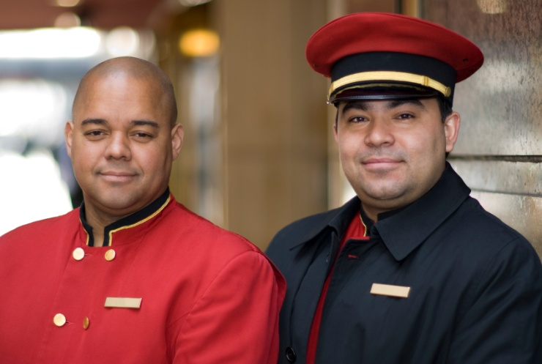
Work Projects
It is a requirement of this Unit you complete Work Projects as advised by your Trainer. You must submit documentation, suitable evidence or other relevant proof of completion of the project to your Trainer by the agreed date.
1.1 Students should locate a Hotel in their local area which employs porters and sit in the Hotel lobby and observe the Porters and describe the work
1.2. Students should locate 2 Hotels in their local area and observe the location of the Bell or Porters Desk and list the types of uniformed staff
1.3. Print a copy of the Code of Ethics. What is the purpose of this code? Using the Internet, check the Les Clefs D’Or web site and explain why is a concierge who is a member of the Society of the Golden keys important to a Hotel’s prestige?
1.4. Using the internet find a picture to illustrate the good grooming and personal presentation of a Porter
1.5 Methods of address. Research how staff would address the following:
Rank | Method of Address in English | Method of Address in Local Language
King
Queen
Prince
Royal Duke
Duchess
Ambassador
President
Prime Minister
Mayor
A Judge
Governor
1.6 A guest has asked for information research 3 of the following:
Include information about location, transport, cost and what experiences the guest will have:
- A local Historical site
- A local Zoo or animal park
- Sporting location
- Local theatre performance
- A local exhibition.

Summary

Identify the role of a bell boy/porter
Bell Boy or Porter services are a main feature of a luxury Hotel or resort, and a requirement for [5] five star or above rating system. In a lesser rated Hotel or resort there are still Bell Boy or Porter services but they are mainly to store guests luggage or provide trolleys.
The term Concierge is used to describe the supervisor or Department head in this area, the concierge is the person in charge of the uniformed staff. Uniformed staff comprise the porter, door person, guest services, chauffeurs, valet parking attendants and messengers.
The porter maintains constant contact with guests and must therefore possess certain qualities that are representative of the individual and the venue. The porter must be attentive and courteous to the guests needs and be organised in way they tackle every aspect of their job.
Porters should have a high regard for personal grooming and hygiene. Ethics and professionalism are important for staff in this area as seen in those Concierges who are members of the Le Clefs D’Or.
The porter’s role is to provide a range of services to guests that may not be available through other departments. Despite not generating revenue, on a porter’s recommendation, a guest may use facilities and services offered by the venue that do earn revenue. A porter has excellent opportunity to read the guest and suggest a Hotel services that would help relax them.
When addressing Guests a porter should look at the guest and speak clearly, accurately, and with the appropriate volume it may be appropriate to use body language to show the way, if necessary always smile, be courteous and polite. Recommending and advising guests of places of interest and upcoming events.

Element 2:
Assist with guest arrivals

2.1 Prepare for expected guest arrivals

In preparation for guests’ arrival, Porters will need to check front office reports for Arrivals, expected departures, trace and special reports and any expected VIPs.
The Arrivals List provides information to many departments, one of which is uniformed Staff, where it assists the porter in efficiently checking all incoming guest requests and information. In some venues this may include a photo of the guest to aid recognition.
Whether the Arrivals List is manually or computer generated, the information found on it must always be treated in the strictest of confidence and should never be left unattended for public viewing.
Information found on an Arrivals List may vary from establishment to establishment, but can be expected to include:
- Arrival date and method of travel, the estimated time of arrival (ETA)
- The departure date and estimated time of departure (ETD)
- The guest’s name, or the name of the reservation
- The number of guests
- The room type and special requirements for room features
- The market segment
- The room rate and whether the booking was guaranteed or not
- Any special requests that have to be prepared, for example removal of the mini bar or a charger for an iPhone.
The Arrivals List is a necessary tool in the planning undertaken to receive guests. It helps to inform management and staff of details and special requirements.
Staffing Levels | Determining the number of porters required to meet shift demands. If a number of tour group busses are expected then it will take several Porters to assist guests, unload and distribute luggage in a timely manner.
Planning of daily tasks | When not assisting guests Porters may have to collect mail, distribute newspapers or run errands.
Prepare for group arrivals | Such as tours this requires co ordination with front office staff for room allocation and key dispersal, having a dedicated luggage storage section and checking all information is ready to give to the tour members such as breakfast location and time, meeting areas arranged and up to date list of hotel services.
Organising luggage storage areas | Especially for large groups of guests who may be on a tour, or who have all come off a recently landed plane.

2.2 Comply with special requests
Special requests are a common occurrence in most accommodation establishments.
The front office usually takes these special requests, with the original booking of the room or face-to-face with guests at check in or during their stay. The actual filling of these special requests requires a team effort and frequently it is the porter who is required to assist in ensuring special requests are fulfilled in accordance with requirements and establishment procedure and policies.
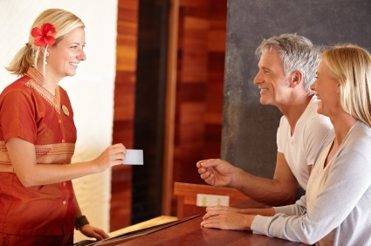
Porters need to liaise with staff from other departments to meet and prepare to meet guest’s special requests – which may include items such as preparing for guests with a physical disability, a request for a bottle of wine on arrival in the room, a fruit platter, chocolates, or a cot in the room.
In an establishment with an electronic Property Management System special requests can be logged as traces. Traces are electronic messages from one department to another identifying by login tag who has processed and accessed the trace. Each department can print their trace or special request report to check all requests have been completed.
Porters may liaise with housekeeping to provide extra equipment such as printers, play stations or coffee makers a guest may have requested. If a guest is a VIP then there may some standard extras added to the room or suite depending on the level of VIP. Extra furniture may be requested such as a child’s cot or desk chair.
Liaising also with Room service staff may also include delivery of floral arrangements, fruit or local produce baskets or a different brand of snacks or newspapers.
In house protocols for pre-arrival information available may include:
- Guest name/s, title (if appropriate) – Doctor, Sir, Mr, Miss
- To personalise the welcome guest profile can include family information – number and age of children, together with their sleeping arrangements, and room number(s)
- The number in party – and designation of those involved this may include the names of staff such as the secretary, or the trainer, or the nanny
- There may be special security arrangements or extra security staff.
The profile may include a company name and business information, the nature of the business. Information will also include personal preferences, for brands of beverages, newspapers, confectionary preferences such as the preferred colours of jellybeans, the preferred temperature level of air-conditioning, even the preference of wake up time, and information on the type of car.
There may also be information about the guests itinerary, where the guest going and when? What arrangements are staff expected to make in order for the itinerary to work?

2.3 Assist guests on arrival as required
The concierge or bell desk is usually located in the front foyer or lobby of a Hotel or Resort in an area close to the driveway and front doors. The porter is usually the first representative of the establishment who meets face-to-face with the guest and this meeting can therefore have a lasting impression. The moment the porter identifies a guest, they should immediately acknowledge them and not wait for the guest to make the first move.
When guests arrive the porter should welcome them warmly, the Establishment may have a protocol for greeting guests. As part of the greeting, offer assistance to guests. When assisting a guest out of a car or from a bus support the guest under the elbow to steady them. Check the number and type of luggage the guest has for and then the porter will collect the luggage from the car, bus or shuttle or other transport. Porters may check luggage for damage or irregularity.
The Porter will direct the guest to reception and if the guest has limited local language, body language will indicate the direction the guest should go.
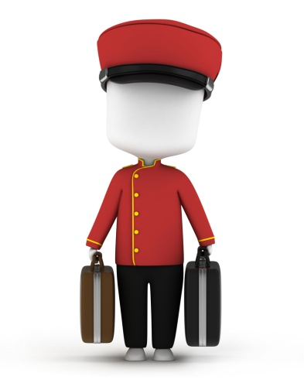
Porters are responsible for driveway security and may need to direct buses and taxis to parking areas. If the guest has arrived in their own car a Porter or valet may park the guests’ car this may be a venue s own car park other venues may rent parking spaces from a commercial car park close by.
If guests are arriving by transit bus or airport shuttle then porters may have to greet guests at a drop off point.

2.4 Escort guests to rooms
When the guest has checked in a porter may escort them to their room or follow later with the luggage. As the porter escorts the guest they need to ensure that guests are going in the right direction and allow the guest to set the walking pace, even when the porter is leading the way. The Porter has an opportunity to market or sell hotel features or services as well as point out the location of meeting rooms to a guest attending a conference or the area set aside for a tour group breakfast or other areas such as dining, bars, sports facilities, entertainment. A porter will also mention in- house facilities such as laundry, cleaning, repairs, secretarial, child minding, translator, room service), in room facilities (mini bar, movies, internet, safe deposits.
A porter may suggest or offer additional services to reserve table at the in house restaurants or dining areas, the location of the guest services desk, or maybe a spa booking for a guest tired after a long flight, or offer to book a reservation at an entertainment or sports event or even reserve a court or tee time for racket sport or golf the trip to the guest room may also include discussing upcoming events in the town or city especially those that will impact on the guests stay.

Rooming the guest
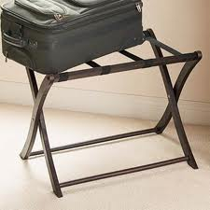
While the porter is escorting the guest to their room they have an opportunity to advise the guest of the venue’s emergency evacuation procedure, answer any questions the guest may have. When arriving at the room location the porter will explain how to use the key, insert the key if it’s a metal standard key, mention which direction to turn; if it’s a magnetic key card, insert into the slot and wait for the light to turn green then open the door. Having opened the door the porter will do a visual check to insure the room is ready for occupancy, and then the porter will allow the guest to enter and follow with the luggage.
The room may have a suitcase rack or support to place a suitcase, hanging items will be placed in the wardrobe, vanity cases or makeup bag will be places in the dressing area or bathroom, briefcases or laptops or other personal items will be placed on the bed. The porter will always seek the guest’s approval before positioning items.
For example:
- Mrs Collins would you prefer your makeup bag in the bathroom?” or
- Mr Ling, can I put your laptop on the desk or would you prefer it on the end of the bed?”
When opening the door may involve a metal key or more frequently a key card with a magnetic strip the card is inserted into the door and may have to be placed in a slot inside the door to activate the main power switch turning on lights and TV with a welcome message. The newest form of ‘key’ is to use an app sent to a mobile phone to access the guest room.
The porter will point out room features to the guest; explain the operation of air conditioning or temperature control, access to intranet, guest messages, telephone and curtains and window features. Also the porter will point out the location of the compendium and other hotel information and explain the min bar procedure especially if it’s a mini bar with direct charge capability.
Finally the porter will ask if there is anything else they can do, return the key to the guest and wish the guest a pleasant stay.

2.5 Adhere to enterprise policies and procedures for luggage handling
The porter should always remember that the luggage they carry belongs to someone else. All luggage should be handled carefully it may contain breakable or fragile items.
Luggage should also be treated as an item of great value and never be left unattended, particularly outside the hotel entrance. On arrival a porter may tag luggage with a hotel tag identifying the number of items and guest name and room number, a luggage tag will also include an expected Date of Departure.
Most accommodation establishments have luggage labels to identify and confirm the ownership of luggage to ensure the security of the luggage. Luggage labels or tags will ensure the luggage is delivered to the owner.
The tag will indicate:
- Whose luggage it is (guest name)
- Guests room number
- Group name (if appropriate)
- Number of pieces, often expressed as a % 1 item of a total of 4, e.g. 1/4 then2/4 and so on
- Type of luggage, suitcase, soft pack, sports bag, sporting equipment, make-up bag, briefcase, laptop etc.
The porter should always use luggage labels to write the guest’s name and room number on as soon as this is known. The label should then be attached immediately to the guest’s luggage.
It is most important for the porter to ensure that all luggages are labelled accurately.
Sending the wrong luggage to the wrong room causes annoyance, poor guest relations, and embarrassment and has the potential to lead to theft, and breaches of privacy.
Occupational Safety and Health; Luggage can be heavy – sometimes very, very, heavy – and therefore the porter must be aware of some basic occupational safety and health issues regarding handling luggage, including:
- Test the weight of bags before lifting – give them a test lift
- Adopt the correct posture for lifting
- Keep the back straight
- Bend the knees
- Lift the luggage.
Use an approved trolley if luggage is too heavy to lift comfortably and correctly.
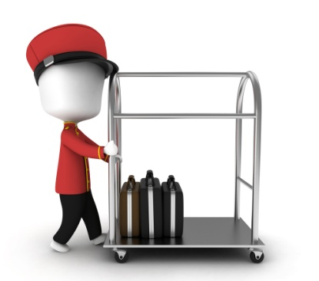
If more than one item is to be placed on the trolley, the heaviest bags should be placed on the bottom and the lighter ones near the top.
If an item is too heavy to pick up, the vertical trolley should be used as the porter will not have to personally lift the bags. Most trolleys have a number of ‘hooks’, which allows the porter to hang garment bags, handbags and other light items with handles. A porter should ask the guest if they want any personal items or delicate items on the trolley or would they prefer to carry them.
In some establishments, specific routes for the trolleyed transportation of guest luggage have been identified these should be adhered to where they apply.
In very large hotels there might even be a conveyer belt to get the luggage from the arrivals area to the reception area or even convey the luggage to the required floor or wing of the hotel.
Likewise, some establishments have procedures for where certain luggage should be placed within rooms – articles on hangers may have to be hung up, suitcases to be put onto the appropriate racks, briefcases next to the bed, and so on: these must be adhered to with every guest in every room, unless the guest requests something else.

Group arrivals
As a tour group or convention group arrives usually by bus and luggage is unloaded and transported by the driver and/or porter to designated area, some hotels or resorts have a designated porter and front office reception staff to greet and check in groups. Or have a special group check-in reception area.
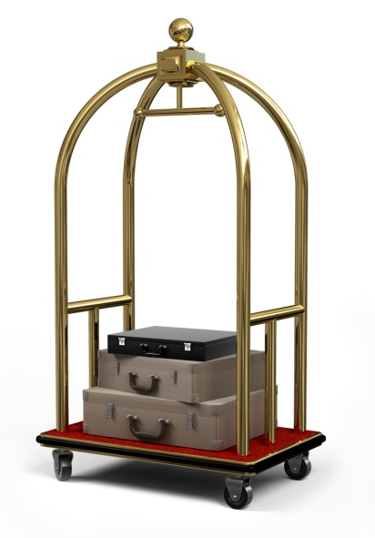
The porter will count and record the luggage on the group file. Receptionist checks Rooming Lists and all relevant information for correctness and smooth check-in process.
- Luggage is tagged by the porter
- Porter obtains Rooming List and places room numbers on tags
- Luggage is distributed to the different floors/rooms.
Luggage may need to be stored at the time of arrival or departure. At the time of arrival, a guest’s room may not be ready. To give the guest the freedom to leave the venue without the inconvenience of holding onto their luggage, the venue will store it for them. Conversely, at the time of departure, the guest may be required to vacate the room by 11.00 am but not due to leave until that evening. Again, the venue will store the guest’s luggage for them until required.
Many venues use a trolley to transport luggage but it is still necessary to lift the luggage onto and off the trolley. When stocking the trolley, place large, heavy items on the bottom and place first those pieces of luggage that are to be delivered last.

Work Projects
It is a requirement of this Unit you complete Work Projects as advised by your Trainer. You must submit documentation, suitable evidence or other relevant proof of completion of the project to your Trainer by the agreed date.
2.1 Arrivals report:
- Using the following table list the arrivals from earliest to latest
- Now structure a job list to meet all the requests and identify which other department the Porter may have to liaise with.
Guests Name | Number of guests | Estimated time of arrival | Comments
Mr. Mammadov |  | 1500 | Return guest: fruit basket in room
Ms.Chea | 1 Adult  1 infant under 2 yrs | 1400 | Baby cot and pram required in room on arrival  Late checkout at 1500 hours.
Mr. & Mrs. Jadhav | 2 Adults | 1100 | Champagne on arrival/ wedding anniversary 30th. Welcome card from manager to be placed in room
Mr. Cruz & Assistant. | 2 Adults | 14.30 | Early arrival. Room must be ready. Room adjoining for personal assistant. Limousine pickup at International Airport. 0645 Hours. Requested second car for luggage. Champagne, fruit and flowers, welcome card. Duty Manager signature
Wing-Lee Family | 2 Adults  3 Children | 1100 | Request interconnecting rooms & rollaway bed
Mr & Mrs Whaid | 2 Adults | 1500 | Mr Whaid requires a wheelchair transfer to room
Mr & Mrs. Nguyen | 2 Adults | 1400 | Wish to store luggage on departure — returning
Mr. Phan | 1 Adult | 1600 | Requested a laser printer and I Phone charger in room
Mr. Huang | 1 Adult | 1400 | Room away from elevators
Vista Tour Group | 34 Adults | 0800 | See rooming list attached. Had problem last stay with luggage going to wrong rooms. Please take care.

2.2. Research local retail outlets in your city and identify where and the cost of obtaining the following special requests for guests.
- A bunch of yellow roses
- A bottle of French Champagne
- A box of Belgian chocolates
- Local authentic national dress
- A cigar.
2.3. Porters will welcome Guests to a Hotel or resort with the words 'welcome to our Hotel'. Research how to say this phrase in [3] three languages common to tourists in your area.
2.4. Create a role play for escorting a guest to their room include conversation with a guest about emergency procedure, hotel services and descriptions of [2] two or [3] three room features.
2.5 Use the internet to identify correct lifting and stacking procedures for luggage, complying with local occupational safety and health or labour laws.

Summary

Assist with guest arrivals
In preparation for guest’s arrival Porters will need to check front office reports for expected arrivals, expected departures, trace and special reports and any expected VIPs. Whether the Arrivals List is manually or computer generated, the information found on it must always be treated in the strictest of confidence and should never be left unattended for public viewing. The Arrivals List is a necessary tool in the planning undertaken to receive guests, it helps to inform management and staff of details and special requirements.
The front office usually takes these special requests, with the original booking of the room or face-to-face with guests at check in or during their stay. The actual filling of these special requests requires a team effort and frequently it is the porter who is required to assist in ensuring special requests are fulfilled in accordance with requirements and establishment procedure and policies.
The concierge or bell desk is usually located in the front foyer or lobby of a Hotel or Resort in an area close to the driveway and front doors. The porter is usually the first representative of the establishment who meets face-to-face with the guest and this meeting can therefore have a lasting impression. When guests arrive the porter should welcome them warmly, the Establishment may have a protocol for greeting guests.
When the guest has checked in a porter may escort them to their room or follow later with the luggage. While the porter is escorting the guest to their room they have an opportunity to advise the guest of the venue’s emergency evacuation procedure and answer any questions the guest may have. When arriving at the room location the porter will explain how to use the key and having opened the door the porter will do a visual check to insure the room is ready for occupancy and then the porter will allow the guest to enter and follow with the luggage.
Luggage should be treated carefully and never be left unattended, particularly outside the hotel entrance. On arrival a porter may tag luggage with a hotel tag identifying the number of items and guest name and room number, a luggage tag will also include an expected Date of Departure.
When handling luggage:
Adopt the correct posture for lifting
Keep the back straight
Bend the knees
Lift the luggage.
Use an approved trolley if luggage is too heavy to carry by hand. If more than one item is to be placed on the trolley, the heaviest bags should be placed on the bottom and the lighter ones near the top.
A tour group or convention group arrives usually by bus and luggage is unloaded and transported by the driver and/or porter to designated area. Luggage may need to be stored at the time of arrival or departure.

Element 3:
Assist with guest departures

3.1 Respond to guest requests for help when departing
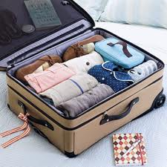
Prior to departure, the porter or valet will need to assist the guest to pack their luggage. The guest may need extra bags or paper to pack delicate items. The guest may need extra laundry bags for dirty clothes and plastic shoe bags for shoes.
The following are some guidelines to follow when packing:
- Don’t start packing until you are fully prepared and aware of everything that needs to be packed along with the bags/luggage that you have to pack into
- Make sure you have all items that need to be packed – where unsure, ask the guest: many guests will want to carry/pack some things themselves
- Fold clothes according to establishment requirements/procedures
- Pack shirts in folded pairs reversed and toward each other
- Pack the front of garments toward the front and top of the luggage
- Place shoes into plastic bags, inserting shoe-trees as appropriate
- Pack shoes with the soles flat against the sides of the luggage
- Pack luggage with heavy items at the bottom and lighter items on the top
- Complete the packing with a towel to cover all items.

3.2 Transport luggage for departing guests
When a guest is ready to check-out of their room, a porter may be required to assist the guest with their luggage, or the porter will be asked to take the luggage down to the reception area or storage area and the guest will check-out later some guests may carry their luggage to the check-out desk.
The porter will usually be advised as to how much luggage has to be moved and the type or approximate weight of the luggage. A trolley may frequently be needed and the porter should check with the guest, if they are present, if all items are accounted for, if the guest is not in attendance the porter will use the luggage tag to identify the number and type of luggage, alternatively the front desk will include the number and type of items the porter is to collect.

The porter should arrive at the room in plenty of time to ensure that guests complete check out in a sufficient time for the guest to meet travel time deadlines. International travellers are required to be at airports several hours before the flight departs. The guest can get very anxious at check-out too. Especially if the guest has a tight schedule or is time poor.
Upon arriving at the guest’s room, the porter should knock on the guest’s door and announce him or herself. On being invited into the room, the porter should inquire as to the whereabouts of the luggage and the number of items, some will be quite obvious but some might be in the bedroom, the lounge or even the bathroom.
If the guests travel arrangements have luggage weight limits then porters will need to weigh all items and inform the guest of any over the limit items as this may incur extra fees.
The porter may need to organise the transport of unaccompanied luggage if the guest decides to send items to their home or business while continuing their trip with fewer pieces of luggage. The porter will do a visual check of the guest room to ensure the guest has not forgotten any item.
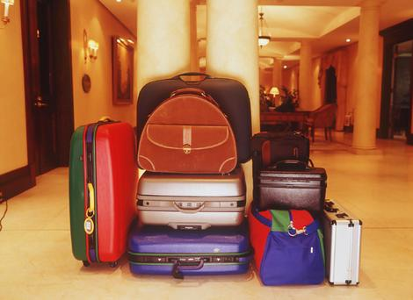
The porter or valet will collect the guest car from the parking area alternatively the porter may need to arrange for other transport, a taxi, or airport shuttle. When the transport ready the porter will load the luggage first confirming with the guest which pieces are to be loaded into the boot or luggage storage compartment and which pieces the guest will carry themselves.
Following check out the guest services desk or bell desk will arrange to forward mail or messages. The porter may need to provide information on weather conditions in the guest's next destination, or on traffic or airport delays, and answer any question the guest may have. A porter may need to provide directions to pick up points or transport locations.

3.3 Operate in-house guest luggage storage facilities
In house luggage storage systems vary between establishments, in terms of their size, location and documentation used. Luggage storage systems or Luggage Rooms are places where guests can store their luggage before they are roomed, or after they have departed their room.
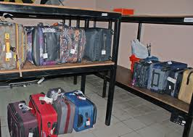
In some cases, the guest may have arrived early at 0600 [6am], if the Hotel or resort had a full house the night before there is no vacant rooms as the guests have not checked out and/or dirty rooms have not been cleaned and notified as ‘room ready’ or ’inspected’. In such cases, the establishment may register the guest offer them a free breakfast or hot beverage or even supply a courtesy room for the guest to bathe and change while they wait, and store their tagged luggage in the Porters store room or Luggage Room. The first appropriate room that becomes vacant will be allocated to them, the porter notified, and the luggage delivered.
In another example, a guest may depart their room at 0900 [9am] and be leaving that evening at 1800 [6pm] on a cruise or flight. The guest may ask that their luggage is kept for them until 2pm to enable them to go and do some shopping before they pick it up and head off to the wharf or the guest may attend a meeting and collect the luggage on the way to the airport.
The Porters store room or Luggage Room would be used for this type of safe storage. The guest’s luggage should have a tag attached. This tag may be a two-part type where one-half of the tag is attached to the luggage, and the other portion is given to the guest for them to use when claiming the luggage.
Other tags simply register the name of the guest whose luggage it is, together with the total number of items stored the guest is asked to provide an approximate time of pick-up so that the porter can determine where in the Luggage Room to physically store the items. Some establishments utilise an alpha storage system, items are stored in alphabetical order, using the guest’s surname as the indicative letter other venues will use a system based on given departure date and time. Where a group is storing luggage, the marking and storing will take this into account – perhaps by using a colour-coded tag or a barcode system. An efficient system speeds things up for porters when they are trying to identify appropriate luggage.
Security is always paramount in luggage storage, and porters or staff must check any dockets or documentation presented to ensure its validity, and only present the proper items to claimants. Staff must always check receipts/tags and never just take a guest’s word for which bags are theirs, the guest say “mine’s the one with the Blue ribbon around the handle”.
Where guests have a complaint that their luggage has been lost or damaged, the establishment policies must be followed. This will include notifying management, taking full written details, making some interim arrangements for the guest, and then deciding whether compensation is payable, and if so how much. Do apologise for any problems but ensure staff never commit the establishment to making any form of compensation without management approval. Establishment policy may require staff to note specifically any damaged luggage that is presented for storage to ensure the guest doesn’t subsequently claim for damage.
The term ‘Porterage’ refers to the fee charged by some venues for the convenience of luggage storage. When porters place a guest’s luggage into the storage system the porter should recheck the number and type of luggage and also consider the size, weight shape. When positioning luggage in the storage area staff also need to consider how long the item is to be stored. Guests trust staff to actually place their luggage into safe storage and this means away from public view and securely located within a protected environment.
The method used by porters and staff to handle luggage is important guests do not want to see their precious luggage tossed carelessly into a bay, or onto a shelf. They don’t want to see someone else’s bags thrown on top of theirs either. Luggage should be grasped by the proper handles, and stood up as intended. Laying luggage flat is to be avoided as it encourages others to place bags on top – and you don’t know what fragile/breakable items there may be inside. Luggage with wheels may be wheeled but handles should be retracted and wheels checked for cleanliness.
If a large group is checking out and there is not enough space in the Porter’s Room or Luggage Room, then the following three possibilities may apply:
- Luggage may be placed in a hotel room or a hospitality room used for this purpose. The room may be the one occupied by a tour leader or the establishments may charge day use rate, 50% of the room rate for such a service
- Luggage could be positioned in one corner of the lobby and roped off. A thick rope goes through all the handles on the luggage so that nothing can go missing. Alternatively the luggage is positioned in one corner of the lobby and it is netted, a large net, similar to fishing net, is placed over the top of the luggage and secured tightly.
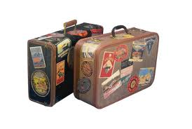
Work Projects
It is a requirement of this Unit you complete Work Projects as advised by your Trainer. You must submit documentation, suitable evidence or other relevant proof of completion of the project to your Trainer by the agreed date.
3.1 Create a collection of information to train a new porter in butler duties of packing a suitcase.
Download information on folding:
- Shirts
- Jackets
- Men's suit
- Men's long pants
- Ladies dress or frock
- Ladies coat.
3.2. Research the various methods of transport a guest could use to get to the airport and the approximate cost.
3.3. Design a system that could be implemented to track and store luggage in a storage room. Include date, weight and name.

Summary

Assist with guest departures
Prior to departure, the porter or valet will need to assist the guest to pack their luggage. The guest may need extra bags or paper to pack delicate items. The guest may need extra laundry bags for dirty clothes and plastic shoe bags for shoes.
When a guest is ready to check-out of their room, a porter may be required to assist the guest with their luggage, or the porter will be asked to take the luggage down to the reception area or storage area and the guest will check-out later some guests may carry their luggage to the check-out desk. When the transport ready the porter will load the luggage first confirming with the guest which pieces are to be loaded into the boot or luggage storage compartment and which pieces the guest will carry themselves.
Luggage storage systems or Luggage Rooms are places where guests can store their luggage before they are roomed, or after they have departed their room. The guest’s luggage should have a tag attached. This tag may be a two-part type where one-half of the tag is attached to the luggage, and the other portion is given to the guest for them to use when claiming the luggage.

Element 4:
Assist other departments

4.1 Support room service requests for assistance
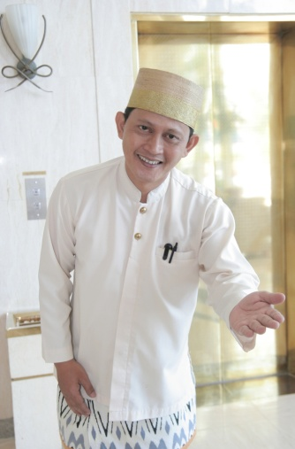
Porters may be asked to perform other duties, in departments short of staff for example room service need to clear a large number of trays or trolleys. Room service may rely on the porters to collect door knob menus while returning from escorting new guests to their rooms.
The guest services desk will use porters to put electronic equipment into a guest’s room such as PlayStation’s or chargers for mobile phones or laptops, coffee making machines or toasters etc. Porters may assist in preparing Picnic requests from guests, Room service will have prepared the food and beverage items but the porters may need to supply tables, chairs, umbrellas, marquees transport perhaps boat or helicopter transport.
Porters may also be required to collect external food deliveries for guests or specialist food items such as imported brands or culturally specific items.
Room service staff have contact with guests and will pass on to porters any specific requests or information such as questions about tourist information or food requests. When servicing VIP guests, especially international guests may request home brand foods, Americans may ask for Dr Pepper, English guests may ask for a specific brand of tea, Australians prefer Cold Beer, Japanese may request a brand of Wasabi, Middle Eastern guests may ask for a specific style of Turkish coffee. Porters may be sent to purchase the items.

4.2 Provide general fetching and carrying duties for departments as appropriate
Porters are among the very few staff of a hotel or resort who are permitted to wear their uniform outside the venue. The important part of porter’s duties is to meet guest requests; this would include booking tickets to the theatres, sporting venues or other entertainment and collecting these tickets.
Porters may need to confirm or change travel arrangements e.g. airline tickets or collect updated Visas from consulates or travel agency. Concierge or porters will be required to make restaurant reservations and bookings. The personal contacts a concierge has will ensure that guest have an excellent dining experience.
Porters may act as messengers for other departments delivering Mail and packages, Hotel reports and memos and supplying one department with items from another, e.g. Housekeeping may send clean towels to the Spa treatment rooms using a Porter to carry them. The Restaurant may have flowers to be collected from a florist before breakfast service or the front desk may have to collect a guest’s passport or visa from a consulate or embassy and again the porters will be the messengers.

4.3 Assist in emergency cleaning requirements
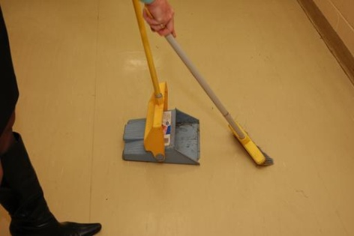
The porters must follow guest requests or instructions regarding the handling of items in their luggage, as each guest has personal needs and sometimes accidents leave clothing and other items stained and in need of cleaning. The Hotel will keep contact details with specialist dry cleaners or fabric cleaners. Some stains may be treated on site by Hotel staff, for example red wine spilt on a guests dress, or chocolate or berry stains. If the guest has played a sport or participated in an outdoor activity, Porters may have to clean a variety of dirt, mud or grass stains.
Hotel staff will have a reference resource on treatment of stains in an emergency. This would include accidental spills within the luggage caused by broken or damaged bottles or product such as body wash or makeup.
Guests who have travelled some distance by a variety of transport may find their luggage exterior dirty or stained and Porters may need to effect emergency cleaning before or after delivery to the Guests room. If the Porters need to send off clothing to be dry cleaned or laundered, the hotel laundry bags may need to be completed with the guests details, the form is usually in triplicate and includes Guest name, Suite or room number, the date. Staff need to tick any of the ‘care’ boxes for same day service or overnight service and check the garment count column and add the colour of the garments and note the location of any stains and their cause, if known. Always check all care labels and wash directions.
Lobby appearance is an important aspect of the guest's first impression; Porters are responsible for the cleanliness of the lobby and driveway. Sweeping or vacuuming soil tracked in by guests, smokers ash trays can be bumped or spilt. There are also accidental liquid spills, drinks or beverages especially if the lobby area is also used for food and beverage service.

4.4 Assist in emergency situations and procedures, as required
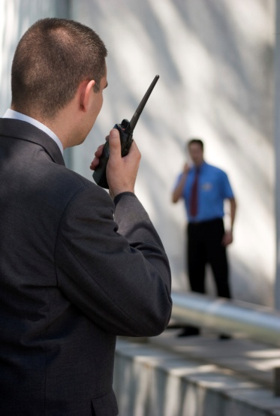
The Hotel or resort would have staff trained in various levels of first aide and policies and procedures for staff to follow in case of emergency. Porters, in keeping a reference file of information to assist in responding to any guest requests, have an extensive list of medical professionals including specialists, dental doctors, chiropractors, physiotherapists, sports therapists and also culturally applicable medical service.
The concierge and porters may be required to assist in emergency situations. Porters are required to explain emergency procedures to guests, this include describing the actions to take in case of fire or emergency evacuation. Guests are instructed to take the stairs not the elevator or lift and to assemble at a safe location; guest registration cards would help account for guests in the case of evacuation. Evacuation can also occur in the case of bomb threat, flood or storm.
Porters are required to assist if a guest is ill or injured, contacting medical professionals. This may include driveway control to enable emergency vehicles to access the venue.
Porters will also be required to assist guests in the case of power failure; their knowledge of the layout of the establishment will assist guests who may be disorientated.
All incidents will be recorded and logged following the establishment’s policies and procedures.

4.5 Back-fill in departments and service areas where required
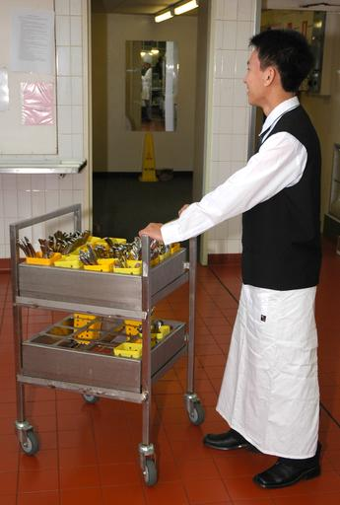
Cross training or multi skilling means that staff are trained to perform in more than one role. This allows for greater flexibility in the tasks and roles each staff member is able to undertake and thus tends to eliminate the possibility of a staff member not being able to fulfil a guest’s request where that request is not part of their normal duties.
Guest requests to the porter can come at any time and may or may not be the porter’s responsibility. But this does not mean the porter doesn’t take responsibility for ensuring the request is met. For example, a guest requesting their room be serviced is the responsibility of housekeeping. However, if it is the porter who the guest asked to clean the room, it is the porter’s responsibility for ensuring the request is completed. In this instance housekeeping is contacted and the request passed on.
Other departments may be short of staff or experiencing an influx of guests. For example if a restaurant has been unusually busy porters may be asked to assist clearing tables and resetting.

4.6 Manage difficult patrons
The porter plays a significant role in minimising the possibility of a security breach. Porters spend most of their time in the public areas of the venue, which means they are in an excellent position to observe the comings and goings of guests and other people. Because any person can access these areas, not just guests, there is considerable potential for security breaches, such as theft and disturbances to occur. A porter needs to be constantly alert to people who seem ‘out of place’, uncomfortable or suspicious
The porter may be required to assist when a disturbance does occur. A disturbance is any incident that interrupts the normal activities of the venue. It may include guests who are having an argument, or are intoxicated or it could be somebody who is attempting to steal or damage the property. People who are causing a disturbance could pose a threat to the venues safety or the safety of guests. Frequently a potential disturbance can be averted if the porters are observant however porters should not involve themselves in a disturbance but contact security staff and the duty manager or department manager. All staff should be aware of the protocols and procedures for dealing with difficult guests.

Work Projects
It is a requirement of this Unit you complete Work Projects as advised by your Trainer. You must submit documentation, suitable evidence or other relevant proof of completion of the project to your Trainer by the agreed date.
4.1 We are a 5 star island resort and a guest has asked to have a special anniversary dinner with his wife on a deserted beach. There is a 3 course meal with beverages to be served at sunset on the beach.
List the items and equipment that would need to be set up on the beach location, include transport, any staff etc.
4.2. Create a list and explanation of International Clothing care label information.
4.3. Using a local directory create a Porters directory section for medical professionals include at least 6 different types of medical service, their location and operational hours.
4.4 Create a manual for new staff identifying the skills and procedures needed to assist in:
- A restaurant to clear tables
- Housekeeping to check requests have been met such as extra beds, cots or equipment
- Room service to deliver VIP amenities or gifts.
4.5 Research and record [5] five actions or ideas to calm difficult customers and disturbances

Summary

Assist other departments
Porters may be asked to perform other duties, in departments short of staff for example room service need to clear a large number of trays or trolleys.
Porters are among the very few staff of a hotel or resort that are permitted to wear their uniform outside the venue. The important part of porter’s duties is to meet guest requests; this would include booking tickets to the theatres, sporting venues or other entertainment and collecting these tickets.
The porters must follow guest requests or instructions regarding the handling of items in their luggage, as each guest has personal needs and sometimes accidents leave clothing and other items stained and in need of cleaning.
The concierge and porters may be required to assist in emergency situations. Porters are required to explain emergency procedures to guests, this include describing the actions to take in case of fire or emergency evacuation. Porters are required to assist if a guest is ill or injured and to contact medical professionals.
Cross training or multi skilling means that staff are trained to perform in more than one role. This allows for greater flexibility in the tasks and roles each staff member is able to undertake and thus tends to eliminate the possibility of a staff member not being able to fulfil a guest’s request where that request is not part of their normal duties.
A disturbance is any incident that interrupts the normal activities of the venue. It may include guests who are having an argument, or are intoxicated or it could be somebody who is attempting to steal or damage the property. People who are causing a disturbance could pose a threat to the venues safety or the safety of guests.

Element 5:
Provide concierge services

5.1 Distribute mail and messages to guests

A Guest purchases more than just a room when they stay in a Hotel or Resort; they purchase intangible products for example security, comfort, luxury, service, and a feeling of importance. Good service will result in guests departing happy, content and relaxed. Porters’ duties are key to satisfied happy guests.
The mail and packages that may be delivered are sorted and then it is common practice for the concierge or porter to be given the mail to distribute to guests and departments. The porter will sort the mail by room number and floor level. Some deliveries may require signatures .Guests may receive information through the internet via the hotels business centre these also may need to printed and delivered.
When mail is received for a guest a porter needs to:
- Check that the guest is registered or if a departed guest that the hotel has a forwarding address
- Record the date and time it was received, if it’s had to be signed for which staff member signed for the mail. Also record name of guest, type of mail item such as letter, Postcard, parcel etc.

Message delivery
All hard copy messages or requests for hard copy messages whether they are phone messages, internet, email or faxes, will be delivered to the guests by the concierge or porter. Many messages can be delivered through electronic property management system guests are notified by a message light or indicator on their TV screen. In some establishments messages can be sent via the intranet or the in-room television or put on voice mail for easy retrieval by the guest. These services will be monitored by the concierge or bell desk.

5.2 Arrange wake-up calls for guests
A wake-up call is a telephone call made by a Hotels telephone operator to a guest at a time requested by the guest. It is a telephone call to wake up a sleeping guest. It is common practice for the telephone receptionist/department to receive the request for a wake-up call directly from the guest. A Concierge or Porter may be required to organise the wake-up call for an individual guest, airline crews and travel groups.
The wakeup call lists include the names of guests in the airline crew or particular travel group.
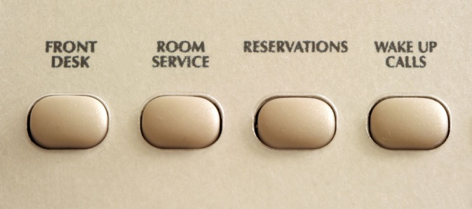
The group leader would usually identify when the group should be given a wake-up call. It may then be the job of the porter prepare a list of guests (the group list) and forward same to the telephone receptionist so that he can give each member of the travel group a wake-up call.
The airline operations office will nominate the pickup time for their crew. Depending on standard procedures the time of the wakeup call is usually 45-60 minutes before the pickup time and then a list of guests is forwarded to the telephone receptionist so each member of the group will receive a wake-up call.
Most hotels have automated wake-up systems which are activated by the guest himself or they provide alarms clocks within the room. Manual wake-up call procedures will vary from property to property but usually involve filling out a ‘wake-up call sheet’ which has columns representing 5-10 minute intervals. If staff receive a wake-up call request they would be required to write the name and room number of the guest that requires the wake-up call in the appropriate column. In the morning the receptionist or switchboard operator would make each wake-up call, throughout the morning, recording each wake-up call as it is answered by the guest.
Some guest or VIPs may request a personal wake up from Room Service or Porters. Staff personally knock on the guest’s door to awaken them usually with a morning service tray with a hot beverage or fruit juice. Porters may have to wake guests who have not responded to the Telephone call.

5.3 Organise transport for guests during their stay
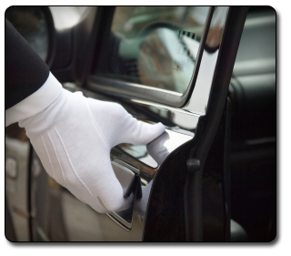
During the guest stay bell boys or porters will a range of transport such as ,hire cars, limousines other local style transport such as cycles, taxis, carriages, water taxi, riding on an animal and bus transport or tours on behalf of the guest. The type of transport will depend on the destination and duration of the travel.
Guest needs such as disability or size will affect the type of transport arranged.
Concierge or porters have extensive contacts with a wide range of tourist businesses and a range of transport methods. Also many external transport businesses will have promotional material and details to encourage a hotel or resort to use their services, especially for the range of animal rides such as horseback, donkey, elephant, dolphins etc.
Group tours will have special arrangements often pre-booked but as many tours include free time for the guests the bell desk or porter will have to meet some extra needs for sightseeing transport.

When arranging transport the porter needs to ask the right question such as
- The numbers of guests travelling
- The destination and terrain to be covered
- Luggage or picnic needs
- Self-drive will need a valid license
- If a driver is required is there a language preference.

5.4 Arrange transfers for departing guests

Asking a guest who is checking out whether he/she would like any transport arrangements made, is particularly important for a guest who is heavily laden with luggage or who does not know what transport is available. Remember, not all guests are experienced travellers. This is an opportunity to make a good lasting impression on the guest especially if the guest has to meet connections for further travel.
A variety of transportation may be arranged for a guest. This may include:
- Courtesy bus
- Hire car
- Limousine
- Taxi
- Helicopter.
A guest may wish to travel by public transport, in which case up-to-date bus, train and perhaps ferry timetables will be needed. When a guest is going to the airport, remember to allow plenty of time when advising as to which bus/train to take.
Whatever form of transport is arranged, certain information is needed:
- The estimated time of departure of connecting transport
- The guest’s name and number of passengers. If children are included then booster seats, capsules or other requirements need to be considered
- The number of pieces of luggage
- Destination
- Any special details, such as flight arrangements/rail details.
Other information that may that may need to be taken into consideration include:
- Whether disabled/wheelchair access is required
- Whether there is a large amount of luggage
- If there are large, cumbersome items to transport.

Once all details have been obtained from the guest, the information is recorded by the porters, if any arrangements the guest has requested need to be altered, discuss these with the guest before arranging them. When the guest is not available, make the arrangements and confirm them with the guest as soon as possible.
Once transportation is confirmed a guest may request that luggage be taken down to the lobby or conveyed to the vehicle. Alternatively, a guest may request that luggage be stored until later in the day.

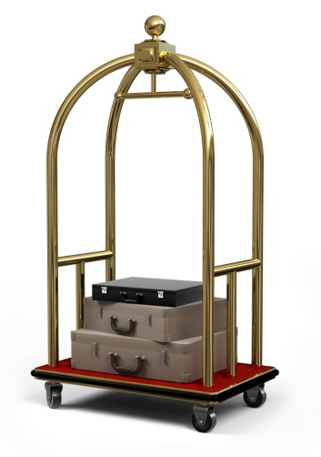
5.5 Organise luggage pick-up from rooms and destinations
The guests will normally contact Concierge by phone when they want their luggage picked up. When speaking to the guest porters should enquire:
- How much luggage there is and the type of luggage, there may be a need for more than one porter and trolley
- Where is the luggage? Guest's room or the guest may have luggage in storage or items to be collected from local vendors or customs agents if they have purchased an item that needs certification
- What time is the guest due to leave the hotel or resort as they may require luggage to be stored for a short time
- Whether the luggage is to be loaded into a car or if commercial transport is to be met.
If the luggage has been stored then the Porter needs to check the tag and verify the guest name and number of items. Luggage may have to be re tagged if the guest is not travelling with the luggage or its being sent to a different location.

5.6 Page guests as required
Historically the process of paging a guest by a bell hop or bell boy who carried written messages around the Hotel ringing a bell and calling out the guests name 'Message for Mr Wu', the hand written message was placed in a slot at the top of the pole or rod the bell was placed on, hence the term bell boy.
Messages are still carried to guests in this way in some hotels especially those with historical or period themes. Currently messages are more likely to be forwarded by text to a mobile phone or accessed on an iPhone or notebook.
Staff are also paged in this way to meet guest requests. With modern VOIP [Voice over Internet Protocol] computer generated messages can be sent instantly, or guest room telephones can be diverted to another location such as the Spa. Porters may use hands free ear pieces to hear requests.
If Mrs Wilson wants to check out she may ring the concierge phone extension, but in fact it’s an internal call centre which relays the message to the first available porter.
Pocket buzzer pagers are also used if guests are asked wait or queue instead of issuing a number token. In larger areas such as leisure or entertainment complexes in a hotel a loud speaker system may be used.

5.7 Prepare in-house guest information/directories
It is the concierge’s role to provide help and information to guests on all matters including:
- All the details about the facilities
- Tourist attractions
- Car hire, taxis and public transport options
- Theatre and dinner bookings
- Airline and other bookings.
Due to the variety of requests, uniformed staff commonly compile a book of information and frequently called numbers this information can be hard copy or electronic.
This information is sometimes stored on computer at the concierge’s desk, enabling easy access by all staff and facilitating the provision of excellent service. Information is found in a variety of directories, guide books, pamphlets and tourist publications. Most establishments have a brochure rack which contains a wealth of information on local attractions, activities, restaurants, etc.

Tourist groups and tour and tour companies, local attractions and government agencies or a local area newspaper, transport timetables, telephone book and locality directory will be invaluable. Whatever material is available, do not simply hand it over to the guest when asked for directions or information. Review the information with a guest and ensure all questions have been answered and staff may offer suggestions or alternatives from personal experience or their local contacts.

5.8 Respond to guest requests for advice and local knowledge
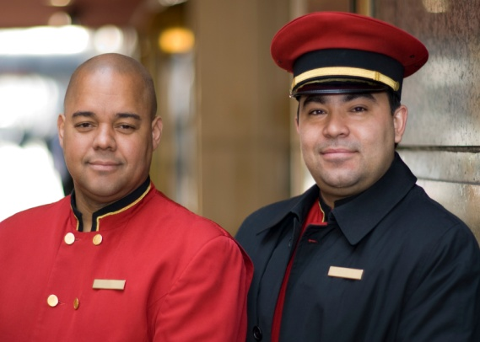
Guests require a range of information and staff in all areas need to be able to supply a variety of information including information about the Hotel or Resort and its services and in house businesses, information about Local attractions and destinations, information about regional destinations and attractions. Hotels and Resorts also seek feedback about services and information in order to effectively and efficiently and provide guests with exceptional guest service.
This includes knowledge of:
- Seasonal influences (e.g., pilgrimage season, best times to see particular flora or fauna)
- Children’s parks tourist developments
- Natural heritage sites
- Local markets
- Museums
- Keep up-to-date with industry information so that you can give guests and junior team members information
- Know what is going on in your property and industry

- Promote products and services and help meet guest expectations.
Up to date knowledge of the property and the local accommodation and hospitality industry shows enthusiasm and commitment. Porters should make sure that they listen carefully to a guest’s request and ask questions to clarify the guests needs and determine how best to fulfil their request. Responding to guest requests for information about the local area might require a porter to:
- Supply phone numbers of a tour/travel agent
- Make personal recommendations
- Supply brochures, business cards, maps etc.

Work Projects
It is a requirement of this Unit you complete Work Projects as advised by your Trainer. You must submit documentation, suitable evidence or other relevant proof of completion of the project to your Trainer by the agreed date.
5.1 Design a document or spread sheet to record incoming mail and delivery
5.2. Design a document or spread sheet to record wakeup call requests
5.3 Honeymoon couple travelling to your area have asked for information about a local historical feature and a fauna park include travel; options and costs in your answer
5.4 Research certification needed to verify if local artefacts and tourists souvenirs can be imported to the guests own country. Suggest a local item and describe how it would need to be packaged
5.5 Using the internet research [2] two suitable paging systems for your establishment
5.6 Design a Compendium for services in your hotel OR Create a compendium for a hotel in your area which has 3 restaurant at least one [1] Bar and a pool or outdoor activity area.

Summary

Provide concierge services
The mail and packages that may be delivered are sorted and then It is common practice for the concierge or porter to be given the mail to distribute to guests and departments. Some deliveries may require signatures .Guests may receive information through the internet via the hotels business centre these also may need to printed and delivered.

Presentation of written work

1. Introduction
It is important for students to present carefully prepared written work. Written presentation in industry must be professional in appearance and accurate in content. If students develop good writing skills whilst studying, they are able to easily transfer those skills to the workplace.

2. Style

Students should write in a style that is simple and concise. Short sentences and paragraphs are easier to read and understand. It helps to write a plan and at least one draft of the written work so that the final product will be well organised. The points presented will then follow a logical sequence and be relevant. Students should frequently refer to the question asked, to keep ‘on track’. Teachers recognise and are critical of work that does not answer the question, or is ‘padded’ with irrelevant material. In summary, remember to:
- Plan ahead
- Be clear and concise
- Answer the question
- Proofread the final draft.

3. Presenting Written Work
Types of written work
Students may be asked to write:
- Short and long reports
- Essays
- Records of interviews
- Questionnaires
- Business letters
- Resumes.
Format
All written work should be presented on A4 paper, single-sided with a left-hand margin. If work is word-processed, one-and-a-half or double spacing should be used. Handwritten work must be legible and should also be well spaced to allow for ease of reading. New paragraphs should not be indented but should be separated by a space. Pages must be numbered. If headings are also to be numbered, students should use a logical and sequential system of numbering.
Cover Sheet
All written work should be submitted with a cover sheet stapled to the front that contains:
- The student’s name and student number
- The name of the class/unit
- The due date of the work
- The title of the work
- The teacher’s name
- A signed declaration that the work does not involve plagiarism.
Keeping a Copy
Students must keep a copy of the written work in case it is lost. This rarely happens but it can be disastrous if a copy has not been kept.
Inclusive language
This means language that includes every section of the population. For instance, if a student were to write ‘A nurse is responsible for the patients in her care at all times’ it would be implying that all nurses are female and would be excluding male nurses.
Examples of appropriate language are shown on the right:
Mankind | Humankind
Barman/maid | Bar attendant
Host/hostess | Host
Waiter/waitress | Waiter or waiting staff

Recommended reading
Note: all Recommended Reading is sourced from ‘Trove: National Library of Australia’ at http://trove.nla.gov.au/.
Baker, S., 2000 (2nd ed’n), Principles of hotel front office operations, Hospitality Press, Melbourne.
Bardi, J.A., 2011 (5th ed’n), Hotel front office management, John Wiley & Sons, Hoboken, N.J.
Collins, S.D., 2009, Managing conflict and workplace relationships, South-Western Cengage Learning, Mason, OH
Cupples, A-M., 2005, Give and receive workplace feedback: PSPGOV315A, Tertiary Press, Croydon, Vic
Hunter, G., Tinton, T. & Mannall, C., 2010, Hospitality supervision Level 3 S/​NVQ, Delmar Cengage Learning, Andover, Hampshire
Kasavana, M.L., 2009 (8th ed’n), Managing front office operations, American Hotel & Lodging Educational Institute, Mich.
Kavanaugh, R.R., 2007, Supervision in the hospitality industry, American Hotel &​ Lodging, Educational Institute, Lansing, Mich.
Powers, T. & Barrows, C.W, 2009, Introduction to management in the hospitality industry, John Wiley &​ Sons, Hoboken, N.J. [electronic resource]
Somers, M., 2008, Coaching, Hodder Education, London.
Sommerville, K.L., 2007, Hospitality employee management and supervision: concepts and practical applications, John Wiley, Hoboken, N.J.
Szende, P., 2010, Case scenarios in hospitality supervision, Delmar Cengage Learning, Clifton Park, NY
Vallen, Gary K & Vallen, Jerome J 2014, Check-in check-out: managing hotel operations, 9th ed., Pearson new international ed, Pearson, Harlow, Essex
Walker, J.R. & Miller, J.E., Supervision in the hospitality industry: leading human resources, J. Wiley, Hoboken, N.J.
Wilson, C., 2011, Best practice in performance coaching: a handbook for leaders, coaches, HR professionals and organisations, Kogan Page, London; Philadelphia.

Trainee evaluation sheet

Provide bell boy/porter services
The following statements are about the competency you have just completed.
Please tick the appropriate box | Agree | Don’t Know | Do Not Agree | Does Not Apply
There was too much in this competency to cover without rushing.
Most of the competency seemed relevant to me.
The competency was at the right level for me.
I got enough help from my trainer.
The amount of activities was sufficient.
The competency allowed me to use my own initiative.
My training was well-organised.
My trainer had time to answer my questions.
I understood how I was going to be assessed.
I was given enough time to practice.
My trainer feedback was useful.
Enough equipment was available and it worked well.
The activities were too hard for me.

The best things about this unit were:

The worst things about this unit were:

The things you should change in this unit are:

Trainee self-assessment checklist
As an indicator to your Trainer/Assessor of your readiness for assessment in this unit please complete the following and hand to your Trainer/Assessor.

Provide bell boy/porter services
 |  | Yes | No*
Element 1: Identify the role of a bell boy/porter
1.1 | Describe the services delivered by a bell boy/porter
1.2 | Locate the position of bell boy/porter within the enterprise
1.3 | Identify the personal characteristics required of a bell boy/porter
1.4 | Describe grooming and personal presentation standards for a bell boy/porter
1.5 | Interpret enterprise policies and procedures for the provision of bell boy/porter services
1.6 | Identify and explain the role of communication in bell boy/porter service provision
Element 2: Assist with guest arrivals
2.1 | Prepare for expected guest arrivals
2.2 | Comply with special requests
2.3 | Assist guests on arrival as required
2.4 | Escort guests to rooms
2.5 | Adhere to enterprise policies and procedures for luggage handling
Element 3: Assist with guest departures
3.1 | Respond to guest requests for help when departing
3.2 | Transport luggage for departing guests
3.3 | Operate in-house guest luggage storage facilities
Element 4: Assist other departments
4.1 | Support room service requests for assistance
4.2 | Provide general fetching and carrying duties for departments as appropriate
4.3 | Assist in emergency cleaning requirements
4.4 | Assist in emergency situations and procedures, as required
4.5 | Back-fill in departments and service areas where required
4.6 | Manage difficult patrons
Element 5: Provide concierge services
5.1 | Distribute mail and messages to guests
5.2 | Arrange wake-up calls for guests
5.3 | Organise transport for guests during their stay
5.4 | Arrange transfers for departing guests
5.5 | Organise luggage pick-up from rooms and destinations
5.6 | Page guests as required
5.7 | Prepare in-house guest information/directories
5.8 | Respond to guest requests for advice and local knowledge

Statement by Trainee:
I believe I am ready to be assessed on the following as indicated above:
Signed: _____________________________ | Date: ____________

Note:
For all boxes where a No* is ticked, please provide details of the extra steps or work you need to do to become ready for assessment.





